Unit 10: Promotional Activities
Introduction

Through my coursework, I’m going to explain the promotional procedures that I am going to do, as part of a group for the promotional campaign of St Saviour’s & St Olave’s School musical production FAME. We’ve been asked to promote the school musical event which is FAME, in order to make the event popular and attract the target market to attend. This piece of coursework will include all the information about our promotional campaign including the methods and procedures we have used or considered, whilst also explaining why we have decided to use it or why we haven’t. The coursework will also include the aims and objectives of the event and what we want to achieve from the promotional campaign, and how we expect to achieve these goals. The coursework will also mention who we want to specifically target campaign and the decisions behind this.

Business Background

The event has been put on to showcase the talents of the students of St Saviour’s & St Olave’s, as they have the chance to use their talents as part of a musical whilst also putting of a show and entertaining for others. St Saviour’s & St Olave’s School is an all-girls Church of England Voluntary Aided school in the Diocese of Southwark and was originally founded as a grammar school in 1903.
Every year, the school put on a full-scale production, in the last three years the school has put on musicals including ‘Oliver’, ‘The Wiz’, ‘The Jungle Book’ and ‘Little Shop of Horrors’ , being the most recent. The students of St Saviour’s & St Olave’s participate in the school event having the chance to be a part of different aspects to the event such as making costumes, make-up, playing instrument, designing sets as well as having the chance to perform, dance and direct.

As we’ve been asked to do the promotional campaign for the FAME musical, we will target intended audience through a number of different methods that we feel can be highly beneficial for the event. We have interviewed both the director and producer of FAME, finding out the basic information about the event and if there were any specific things they would like us to do. When interviewing them, we asked about past school events, and also found out what their main aim was and what they wanted to achieve from the showcasing of the musical FAME. We found that the aim of it was to ‘To showcase the talents of the students of SSSO, by entertaining an audience which includes students, teachers and staff’. FAME is originally a musical based 1980 film which is about New York City's High School of Performing Arts which gives students the chance to begin their journey in the performing arts industry. The musical follows the lives group of vibrant, multi-ethnic, multi-cultural, energetic young people, showing their joys and struggle to reach success. St Saviour’s will showcase FAME for two days on Thursday 7th February & Friday 8th February at 7pm, having the capacity to entertain to 300 people each night.

AO1

Aim & Objectives

Our promotion campaign is constructed through promoting the St Saviour’s & St Olave’s School FAME musical which students have taken part in. The promotional campaign will allow us to plan how we will use our promotional activities in order to create awareness of the FAME production. We will have to promote the event to different audiences which include students, parents and teachers. The overall aim of the FAME production is:

- To showcase the talents of the students of SSSO, by entertaining an audience which includes students, teachers and staff.

It is essential that we use SMART promotional objectives, as they are the key to a successful marketing campaign, the SMART objectives will directly help us to achieve the overall aim of the FAME production. ‘SMART’ is an acronym which stands for Specific, Measurable, Achievable, Relevant and Time-specific. Specific, means that the objectives will be appropriate in terms of the event, therefore they are based precisely around the event which is the FAME production at SSSO. Measurable, allows us to assess the success; therefore we can make sure our objectives are measurable, for example by using a percentage. Also making the objectives achievable, it means that we must assess the capabilities of the events and our available resources, therefore allowing us to set objectives which are realistic enabling then to be achievable. Relevant refers to the objectives meeting the needs of the FAME production and they should be targeted at the right people, therefore in our case this would be the students, parents and staff. Objectives should also be time-specific, therefore they should get out when we want to achieve this by, meaning they should include a particular date. This is especially important because it allows us to keep up on track, making sure we reach our objectives in time in order to achieve our overall aim of the event.

The SMART objectives that we’ve used in order to achieve our overall aim for the FAME production are:
- To sell 550 tickets by 5th February 2013 for the FAME production.
- To create awareness of 90% by 5th February, among students, teachers and parents, measured through the use of questionnaires.
- To make sure at least 60% of tickets are sold to students of St Saviour’s & St Olave’s by 5th February.
- To make sure at least 20% of tickets are sold to parents of St Saviour’s & St Olave’s students by 5th February.
- To make sure at least 5% of tickets are sold to staff of St Saviour’s & St Olave’s by 5th February.
- To spend within a budget of £250.

All our objectives are SMART; therefore they are specific, measureable, achievable, relevant and time-specific. This makes it easier for us to ensure that we achieve the overall aim ‘To showcase the talents of the students of SSSO, by entertaining an audience which includes students, teachers and staff’. Our objectives are specific to the FAME production, and measurable as we’ve used percentages allowing us to asses them. Our objectives are also aspirational yet achievable, making them realistic and relevant as they are targeted to the right audience as we have separate objectives for students, teachers and staff. The objectives are also time-specific as we have set a particular date which is 5th February 2013, this states when we want to achieve this by, this is because the actual event it on the 7th & 8th February.

Range of Promotional Activities Available

There are a number of different promotional activities available in order to help us achieve the aim of showcasing the talents of the students of SSSO, by entertaining an audience which includes students, teachers and staff. However not all of the promotional activities are applicable for us to use due to customer attitudes and resources available.

Sales Promotion
One promotional activity we could use is ‘Sales Promotion’, this is a direct incentive which encourages the purchases of a product, in our case this will be the tickets for the FAME production. Examples of sales promotion are offers such as buy one get one free, 2 for 1, free samples and tokens. We’ve decided we could use this promotional activity as a method for promoting FAME by having an offer which allows customers to buy 2 tickets and get one free.

Merchandising
We looked at ‘Merchandising’ in deciding which promotional activities we could use. Merchandising is used to communicate the product benefits and to present products in a favourable way in the retail environment. We thought that this may not applicable in promoting the FAME musical as we are promoting an event rather than a product, therefore may not be able to use this technique. As merchandising uses products it means using it would also increase our costs as products will need to be made, this is not applicable for us as we have a small budget as it is a school musical and one of our objectives is to spend within a budget of £250.

Personal Selling
‘Personal Selling’ was also considered when deciding what promotion activities we would use to promote FAME. Personal selling is the process of informing customers in order to persuade them to purchase a specific product by communicating with them directly. It’s a highly individual activity and therefore a good salesperson can differ from the way they communicate depending on who they are approaching. We could use this method in order to promote the musical; however the way we communicate with our customers will differ depending on which category they fall under referring to our target audience, therefore could promote FAME differently to the students compared to how we may promote the musical to parents and staff. We could consider promoting fame to parents by directly sending them letters by post, and also texting them about the event; therefore they are aware that FAME is taking place. However one way we could promote the musical to students and staff is through the whole school assembly as they are both in the same location; therefore we can take the opportunity to promote FAME at the same time.

Personal Selling
Another promotional activity we looked into was ‘Advertising’ as it is one of the main forms of promotion and is a very popular method. Advertising is a paid form of non-personal communication which is transmitted through mass media and is used to inform and persuade current customers as well as potential customers. Adverts are placed through the use of television, radio, magazines, newspapers, billboards, bus shelters and the internet, meaning is can attract a wide range of customers. We may choose to use advertising as we think FAME can hugely benefit through this method, therefore may consider setting up a Twitter account as well as a Facebook page via the internet in order to promote the musical through the use of social networking as it is very popular especially to students which are our main target audience. We could also decide to create posters which will contain the information about the event therefore promoting is through the use of images and text, and could place these posters around school and on notice boards allowing our target audience of students and teachers to view them as we could place them in popular areas such as the school foyer. Advertising could also be used to promote FAME as we may mention the event in the internal school newsletter which can be viewed by students, parents as well as staff. We could also display the event on a billboard outside or nearby school as billboards is a very popular method of outside advertising, we could benefit from this as passing pedestrians and drivers will notice it. Billboard advertisements are also designed to catch a person’s attention in order to create a memorable impression quickly, therefore if parents come to pick their daughters up from school they will notice it wanting to attend. We could also consider using the radio and television adverts in order to give out information about the event and attract a wide range of potential customers making the event seem exciting however, as musical is a school event we do not want the public to come and view it as our main target market is students, parents and teachers.

Sponsorship
We also looked at ‘Sponsorship’ which is the involvement of supporting an event in order to promote your brand to make it better known. It helps the image of the business improve by funding activities or events, therefore an organisation may choose to sponsor a popular event in which they can benefit from as there brand name will be shown attraction potential customers. We could use this method by sponsoring through funding a youth theatre day however it may not really be relevant for our event as FAME is only on for 2days therefore it would not really be applicable we also may not have the necessary finance in order to sponsor an external event due to a small budget.

Public Relations
‘Public Relations’ refers to raising awareness through the use of media in order to get noticed by publicity to communicative positive news about a business; however this can also be negative. Public relations could include press conferences and issuing press notices. We could decide to use this method as a way of promoting FAME as we may decide to include an article about how the musical has hugely benefitted a student making them explain the benefits the production would have had on them in the school newsletter, therefore representing the school production in a positive way. We could also use it in order to improve the reputation of St Saviour’s & St Olave’s School positively by donating some of the money made through the showing of FAME to a chosen charity.

Customer Characteristics

We’ve identified out target audience which include three different categories which are students, parents and the staff of St Saviour’s & St Olave’s.

Students
I would say the students of St Saviour’s & St Olave’s are our main target audience, as they would be the most entertained through the musical. The students are females and young and their age will range from 11-18, and therefore they will be most likely to have a low disposable income as they are under 18 therefore we must make sure that the tickets are affordable making sure they are able to purchase one. The students will also be attending school until 3:30pm/4:00pm meaning FAME should be showed in the evening making sure they are able to attend. As they are in school from 8:40am to 3:30pm, we could use this opportunity to promote the musical due to the captive audience, as this can be done by whole school assemblies and posters placed around the school. As the students are young, they’re easily influenced by peer pressure meaning word of mouth is a very popular method of promotion as if they’re friends are going to see it they will also come. Social factors will also be considered as students will more likely to purchase a ticket for FAME is their friends are taking part in the musical in order to support their friends.

Advanced technology also allows us to promote FAME to students, as students are more likely to use social networking websites such as Twitter and Facebook allowing us to target them through the use of technology and the internet. The use of technology also allows them to socialise with their friends and others through social networks sites sharing opinions about the FAME production, therefore also promoting it through the word of mouth. Students may also be more likely to attend if they have previously attended a school musical or performance event or if they are interested in performances due to entertainment. Students will also be more likely to respond to informal medias such as posters and performances therefore we should consider targeting them through these medias.

Parents
Parents are also included in one of the categories part of the target audience for FAME, as the parents and guardians of the students taking part in the FAME production are likely to come and see it in order to support their children and friends. Parents’ gender will vary from both female and male, however mothers will be most likely to come and see the production as it’s a female school as well as a musical, therefore more feminine, as we found out through our secondary research. The age range will be older for the parents, and therefore vary from 30-60 meaning we will have to target them in a more professional way such as through the use of letters rather than social media. Parents are also unlikely to pick their children up from school or be a school, therefore we will have to market to them outside of school, such as texting them or posting letters to them. The target market will be located in London and more likely around the Southwark area; therefore they will be able to attend the event to support their children for both social and personal relations. Parents may also be working therefore they may finish late, meaning we should make sure that they are able to attend FAME, so we can make sure the musical must be showing in the evening making it available for parents to attend. Parents are also going to belong to the W/C or M/C, finding out from our research, therefore will have a higher disposable income, meaning we should make the price of the tickets reasonable but still affordable.

Parents are also more likely to respond to the use of formal and direct Medias such as letters and texts as they are sent directly to them, therefore the event seems important as they have been notified meaning they will be more likely to attend. Parents may also like watching musicals due to their leisure habits and would very much like coming to watch a school event; therefore they would be more likely to purchase a ticket. Parents may also have attended a similar school event or school musical before meaning they would want to come again and watch FAME influencing them to purchase a ticket. Parents may also be more likely to attend as their daughters may be taking part as they would want to be there to show support for their children, meaning we should definitely target them on a personal influences. Another reason parents may decide to purchase a ticket and attend the musical is because they may have an interest in musicals for entertainment purposes however they may not be able to go and watch them due to their working hours, however this school musical gives them the opportunity to attend due to the timing of it, as FAME is showing in the evening providing them with the opportunity to attend as they would have finished work. If parents attend, they may also be like to bring others with them such as friends or children, therefore this would help the selling of tickets for both adult and children tickets.

Teachers
The other category for our target audience for the musical include the staff of St Saviour’s & St Olave’s School, meaning they age will vary roughly from 24-60 and the gender will be both female and males. Staff will be most likely to attend the FAME production in order to support staff, students taking part and the school overall, therefore on an emotional level. As the staff work at the school, it allows us to promote FAME to them during their working hours, this may be done by putting posters up around the school or on notice boards, as well as having teasers in whole school assemblies, allowing us to target both students and teachers at the same time. As they work within the school, and therefore are located at St Saviour’s & St Olave’s, we can therefore promote FAME to them within the school; this will also help reduce costs helping us stay within our budget.

Teachers may have also previously attended school events such as musicals therefore some may be more likely to purchase a ticket and attend as they have an interest in it. Teachers would respond to both informal and formal medias, therefore we could target them through both ways using posters as well as letters in order to encourage them to attend to also support to school and students.

AO2
Promotional Mix
Method | Resources Needed | Timing | Cost
Advertising - Posters | Computers, Printers and Paper | 1 week | 5p per A4 (60 x 5p = £3)  10p per A3 (5 x 10p = 50p)
Advertising – Social Media | Computers | 2 weeks | Free, due to it being available at school
Advertising – TV Screens | Computers and TV Screens | 3 weeks | Free, due to it being available at school
Personal Selling – Assembly Slot | Microphone | 1 week | Free, due to it being available at school
Personal Selling – Letters | Computers, Printers and Paper | 2 weeks | 5p per A4 (160 x 5p = £8)
Merchandising – T-Shirts | Computers | 1 week | £4.50 per T-Shirt  (25 x £4.50 = £112.50)
Sales Promotion - Ticketing | Computers, Printers and Paper | 2 weeks | £40

As part of our promotional campaign to promote the FAME school musical, we’ve decided to use a mixture of methods to do this which include posters, letters, t-shirts, sales promotion, an assembly slot, SSSO TV screens and the use of social media. We’ve chosen to use these particular methods as we believe these would be the most suitable for promoting the school musical, therefore the campaign can benefit from this.

Using posters to promote the FAME event is essential as they catch the target market’s attention whilst also informing them of the event, therefore grabbing there attention. We felt the use of posters will grab the attentions of those who walk by as they will be eye catching, therefore stand out making the target market want to read and find out more information about the upcoming event. Posters can also act as a teaser, as they are a tool for making people look forward to the event as they can make the audience feel excited for the upcoming event, whilst also promoting it at the same time. We feel that using letters is another important method of promoting FAME as they inform the target market, therefore persuading them to come to the event. It’s important that the letters contain persuasive language in order to encourage the potential viewers to come to the event; therefore the letters must grab their attention making them want to attend. T-shirts are also another important method that we have decided to use when promoting FAME as they allow the target audience to be familiar with the upcoming event, as they will see shirts associated with the musical around and others will wear them, therefore making the target market feel that they cannot miss the event.
Sales promotion provides us with the opportunity to promote FAME in order to attract a larger number of viewers through the use of offers. We’ve decided to use this direct incentive to encourage the audience to purchase tickets at and offer which is buy 2 tickets and receive the third for free, giving us the opportunity to attract more viewers. Another method we’ve decided to use is an assembly slot, as part of the whole school assembly as this is a great opportunity to promote the musical to both students and teachers, making sure they are familiar with the event. As part of the assembly slot, we will give them a teaser, in which a small part of the musical will be acted out, therefore encouraging them to attend the actual musical. We feel that the use of social media can hugely help us to promote FAME, as social media is very popular in today society, meaning we chose to take up this opportunity by creating both Facebook and Twitter pages which will help increase the popularity of the FAME school musical. Another method include using SSSO TV screens, in which we will be making the most of school resources as they provide us to promote FAME via using the TV screens around the schools, therefore they will show information and images of the upcoming event, allowing the audience to familiarise themselves with the event.

Resources

Human Resources
The use of our human resources is essential in the process of our promotional campaign for FAME as it’s important that we make the best use of the people involved whilst also making sure they have the necessary skills required in order to achieve the best result and meet our aims and objectives for the musical. The human resources that are available for us to use include ourselves who are conducting the promotional campaign as well as a number of teachers and students which are a part of FAME and media students. This is very helpful for the promotional campaign it means that we will not have to spend money on the use of other expertise as the students and teachers will be doing it free of charge as they are within the school. This would then also help us to achieve our objective which is to spend within our budget of £250.

As we are conducting the promotional campaign for the FAME school musical, it is necessary that we have the skills required to do so. As a team we all possess team working skills, as we have the ability to work as part of a group with one another, all sharing ideas and working together in order to achieve the overall aim for FAME which is ‘To showcase the talents of the students of SSSO, by entertaining an audience which includes students, teachers and staff’. As a team we are willing to help one another out in order to complete a task as we are required to work towards a coordinated campaign which involves different elements, therefore are able to communicate with one another appropriately. We also have communicational and interpersonal skills which allow us to communication effectively with our team members, whilst also which others involved in the musical and most importantly the target market itself, which includes students, teachers and parents. We are able to build an understanding of consumer needs, therefore understanding the needs of our target market, we have a benefit from this as we are students as well, and therefore can relate to the needs of our target market. We also have good technical and IT skills, this is essential as todays modern society requires the use of technology as it plays a big part in promotion, all of our team members have a clear understanding of how to use technology and therefore are able to use it in order to complete tasks. IT skills are necessary, as our promotional campaign includes creating posters and letter which means they will have to be created using technology on a computer, as they will have to look professional and appropriate to the task.

A number of different teachers are also a part of our human resources, as some are involved with the production of FAME, therefore they are able to help us with our promotional campaign. The teachers who are involved have the necessary skills and expertise as well as the authority to do things and make decisions, therefore they can help us with our promotional campaign. Some students who are in the FAME musical are also included as part of our human resources as they are able to help us with some promotional methods as they will be required to take part, for example, in the assembly slot, they will have to perform a tiny section of the musical as a teaser for the target market.

We’re also working with a-level media students as part of our promotional campaign as they have the necessary skilled required in order to create medias which can help promote the musical. For example, they possess good technical skills as well as creativity/imaginative skills and are able to create good designs needed for posters and presentations which will be played on the SSSO TV screens and placed around school. However, they will not always be available as they do have their own work to do, therefore we will have to work with them when they’re available. Working with media students on the event will also increase word of mouth, attracting more students to come and watch the play, this can also help achieve objective to create awareness of 90% by 5th February, among students, teachers and parents.

Physical Resources

As we are promoting for the school musical, it means that we have a number or physical resources that are already available for us to use within the school, however some we may have to use externally. Being a part of the school means we can use the technology available in order to conduct the FAME promotional campaign, this can be very beneficial as it lower our costs helping us to stick to our overall budget for the campaign itself. The physical resources available include photo copiers, which allow us to copy important documents such as letter of notices about the musical. Computers are also included, allowing us to create the posters, letters as well as presentations as they pc’s have the appropriate software needed to create them making them look professional. Other physical resources include the sound system, microphones and TV screens, which are available for use to use in order to promote the musical as we will need to sounds system and microphone during our assembly slot and the TV screens are going to be used as part of one of our promotional methods.

Even though most of the physical resources are available to use within the school, we will have to go externally to design our t-shirts as we did not have the necessary equipment and machinery which was needed. As a result, we decided to go to a printing shop located in Greenwich called ‘LPS London’, as they are also experts in digital printing, however as they are external, it does mean we will have to pay for the printing of our t-shirts.

Financial Resources

Financially, our budget for our FAME promotional campaign is £250. This is a good amount as it is a school production, and therefore not a lot of money will have to be spent on unnecessary items. A lot of the equipment we need is also available for use within the school itself, therefore benefitting us as we will have to only pay a small amount in order to use it, therefore tasks such as printing will be cheaper than getting it printed externally. As the overall event, the FAME musical is only on for two days it means that a lot of money will not have to be spent in order to promote it, as it means we won’t be spending a ridiculous amount of money for an event which is only showing for two days. Our costs will also be quite low as it’s a captive audience so they already warm to the promotional message therefore we will not have to spend a lot financially on promotional activities. Most of the money will be spent on printing as part of promotional methods, such as printing posters, letters and the t-shirts. However as the majority of it is done in-house (internally at school), costs will be minimal, for example we will get the HR for free and will not have to pay for the assembly slot or the equipment used for it such as microphones, this will also help us to achieve our objective to spend within our budget of £250.

Research conducted

In order to help us with the campaign for the musical, we conducted primary research in which we created questionnaires as well as interviewing the director and producer of the FAME musical. These results helped a lot as we were then able to decide what actions should take as we identified which action would be more beneficial and applicable.

Interviewing the director and producer allowed us to decide which methods would be the best as we asked details about which methods that were used in the past, therefore seeing how we could use them due to it being successful. Referring to the interview(in the appendix), we then decided to best price for tickets as it would be useful for the target market if ticket prices stayed the same, this will help guarantee that the demand will be high for the tickets as the price will be familiar and therefore affordable. The interview also helped us make new decisions as we asked then who had brought the most tickets in the past, allowing us to identify the main target market, however the response was that it was unclear as there was no record of it. From this we then decided that we would create a system which we will keep record of the tickets being sold, therefore there will be information on who brought the tickets and whether it was an adult or child ticket. This system will then help us in the future with any school events, allowing us to target the most popular target market based on previous information. The interview also helped us find out the basic information about the event such as the location, time and date, then helping us include this information in our promotional methods such as posters.

We also conducted primary research on our target market through questionnaires and a consumer panel as we created different questionnaires for students and parents whilst also asking 5 teachers questions in order to help us gather separate information based on which category they would fit into. We found this information out before the musical event in order to help us which the promotional methods we would use for campaign.

For the questionnaires for students we asked one Year 9 form class which has 20 students, we then asked them basic questions which will help us for the campaign such as which questions they find attractive and if they use social media. The results from this will then help us decided which methods we would use. The results from the questionnaire are displayed below. The responses will then help us make decisions based on the design of posters and the locations we would put them up as well as the TV screens, ticket pricing and the use of social media. For example, looking at the results, it will then encourage us to design the posters making sure the colour scheme is red and black in order to attract more of the target, especially as the students are our main target audience.

We also conducted a questionnaire for parents, asking 10 parents some basic questions, we only chose 10 parents as we found that it was hard to get hold of parents. We managed to get hold of 10 parents to fill out the questionnaire when they were picking up their children from school. The results from the questionnaire are shown below. The results of this can then help us understand more about part of our target market; therefore we can make decisions which will favour them in order to make sure they purchase a ticket. For example, finding out their occupation can then help us decide the pricing of tickets for adults in order to make sure they are affordable.

Instead of using questionnaire to gather data, we conducted a consumer panel for teachers in which we asked 5 teachers some questions. We thought this would be easier as teachers could answer them together, as it was also quite hard to get hold of them as they are busy during school hours due to work and teaching. This method also allows them to give qualitative answers as open questions were asked, this would be more helpful as we will be able to gain more of an insight of their opinions and responses towards the event as we can gather an in-depth understanding and the reasons why they may hold particular opinions. The results are displayed below.

Questionnaire to member of staff
Consumer panel for 5 teachers

- Do you remember any promotional activities for the school musical that worked well in the past?
I noticed that announcing any notifications or holding any activities during assembly creates more of awareness than any other type. This may be because every year group and teacher is in the hall and are paying attention.
There are always lots of posters up around school for different events so only the really eye catching ones stand out.

- Do you attend any school plays?
Yes, I’m always at many school plays, I find it important to support my students. However as some school plays tend to run a little over time I tend to buy the Friday tickets, I find it much easier due to not having school the next day.
I’m new so haven’t been before but I’m looking forward to going.

- How much are you willing to pay for a ticket?
For most of the school plays I have been to I’ve paid around £3. I don’t mind paying between £1 and £5.
I think anything up to £5 is more than reasonable.

- Do you use social media?
I do use social media like Facebook however I check this outside of school premises as it is not school related. (All agree).

Promotional Plan

Advertising
Posters
We’ve decided to use advertising as the main promotional method for a number of reasons, as we feel that FAME could benefit from this. We will design posters which will be placed all around the school at different locations including notice boards, the foyer and also placing them in registers for form tutors to read and hang up. We decided to design the poster accordingly to the FAME musical theme, taking into account the information should be clear as the main target audience are students, therefore they should be easy to read. We’re making the posters for the event in conjunction with the A-Level AQA media students, as they have the expertise and knowledge about creating posters which will stand out to our specific target market, however they are not always available due to them having their own work, therefore will have to adapt to timings.

The logo of both FAME and the St Saviour’s & St Olave’s School should be clear; therefore the target market can easily associate the poster with the event. The logos will be used continually across the promotional mix to represent the event. We also decided to put the posters up in advance of the event, to make sure the target market are familiar with the event and therefore purchase tickets in advance, we will roughly out them up 6 weeks in advance, making sure they know all the details about the event. We’ve decided that we were going to make 3 different posters not just one, allowing us to promote the musical at different times, as the first poster would be put up in the winter term, allowing a lot of time for the target audience to be familiar with the musical, this poster would give away very little information allowing the students and teachers to look forward to the event. This will also help us to achieve one of our objective which is to create awareness of 90% by 5th February, among students, teachers and parents, ensuring that the event is successful. The second poster would go up in January, giving away more information about FAME such as the dates of when it will be showcased, the timings and also information on when tickets will be sold. Their will finally be a third poster, which will be put up in recognition of the musical a week before, stating that the event takes place in a weeks’ time therefore tickets must be purchased as soon as possible. As the posters will be located in different places, it means that the size of them will also vary; therefore we have decided that the ones that will be placed in the foyer will be A3 size, allowing them to be noticed as they will stand out grabbing the attention of those walking by. The other posters will be A4 size, as they will be placed in registers and around the school, having then A4 allows them to be placed on classroom notice boards, as there may not be enough space for larger ones. We decided not to print any A2 as there is no ability to do this at school and we also felt that it was not necessary as A3 is big enough.

The costing of printing the posters is quite reasonable as we will be printing them in school meaning we will get it cheaper than if we were going to print externally. The price for printing on A4 is 5p per sheet and 10p per A3, therefore as we will be printing 60 A4 posters in total including all 3 designs, it will cost us £3.00 (60 x 5p = £3). As the pricing for A3 is 10p per sheet, it will only cost us 50p as we are only printing 5 A3 posters (5 x 10p = 50p). The total cost for printing posters will be £3.50, however the paper used may not be of high quality, but we felt the price for this is quite reasonable as this will also help us to achieve our objective to spend within our budget of £250.


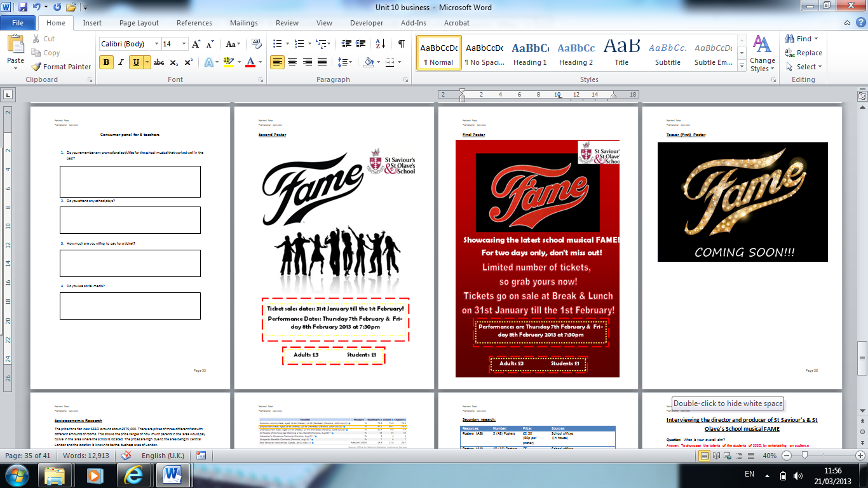
This is the poster that will be put up first, as it gives away very little information, allowing the target market to look forward to the event.
This is the second poster this will be put up; we decided to use these colours taking on board the feedback from our questionnaires we conducted.
This is the final poster which will give more information about the event compared to previous posters. We also chose to use this colour scheme as it we found it was the most popular choice from looking at our primary research.

SSSO TV Screens
We’ve also decided to place adverts on the SSSO TV screens around the school, allowing the students and teachers to find out basic information about the event. The TV screens are located around the school at different places, therefore there is a chance that most people within the school will watch and read the information. Referring to AIDA, the TV screens will give potential buyers the opportunity to find our more information if they show an interest in the event, whilst also making them aware that the event is taking place. This will cover both the first and second stages of AIDA the target market will be aware of the event when watch the screen and will also be able to find out more about the musical due to having an interest.

The adverts on the TV screens will show quite basic information, just at the dates and the timings on the musical. However in order to grab the attentions of the viewers, they viewers images of the musical from the rehearsals will be shown, making the event seem exciting. We will design the adverts with the A-Level media students as well, as they have more knowledge on advertisement, allowing our campaign to be more successful. We will make sure include both the FAME logo as well as the school logo, this is important as the logos allow the viewers to associate the event with the school and the theme of the event itself.

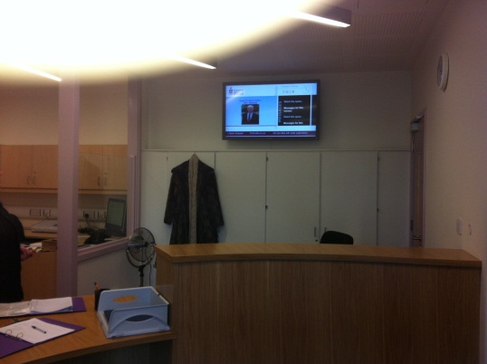
This is an image of one of the SSSO TV screens which is placed in the main reception. The location of the screen means that the adverts can be targeted at parents as well as the student and teachers.

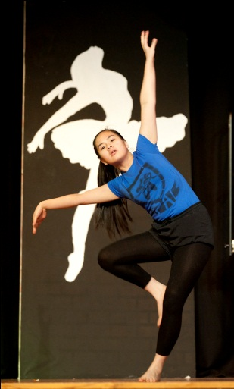

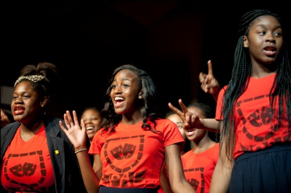

These are some of the images that will be used in the adverts, giving a sneak peak of the event, therefore turning their attention into interest. This can also help us achieve our objective to create awareness of 90% by 5th February, among students, teachers and parents.

Social Media
One of the other promotional methods we’ve decided to use is social media, as social media is becoming very popular as a way of advertising through the use of the internet. We’ve decided to use social media, by creating both Facebook and Twitter pages for the FAME school musical, this can benefit the campaign as it is especially good for the target market as students use social media daily. Using social media to advertise FAME also makes it very easy to update information and post new updates about the event, therefore one person can be in charge of it updating the Facebook page every week and tweeting daily about the school musical.

As our main target audience, the students, use social media a lot, it means they’re able to find more information about FAME whilst also being able to share opinions and comments with others, allowing us to achieves our objective of creating awareness and to make sure at least 60% of tickets are sold to students of St Saviour’s & St Olave’s by 5th February. However not all students use social media therefore we’re not able to target all students, there may also be some restrictions on accessing social media within the school network meaning students will only be allowed to do this externally from school or via their phones.

Personal Selling
Assembly Slot
We will also use an assembly slot as a way in order to promote the musical, which we will fully explain the details of the musical such as the dates and timings. The assembly slot will roughly be a 5 minute showcase, in which the key information will be explained, including where the musical will take place- the location, the dates and timings which it will be shown, and ticket information including the price. A short section of the musical itself will also be played, therefore acting as a teaser, giving the audience a sneak peak of what is to come. The assembly slot is one of our main promotional methods as two of our target markets will be present during the assembly, allowing us to target them both at the same time, saving us both time and money as extra resources are not needed. The audience present during the assembly a captive audience, therefore ensuring that they are aware of the event.
Selling Tickets
We will also use personal selling in order to sell the tickets as potential buyers will only be able to buy tickets in school, not through a third party. We will sell the tickets in personal at break and lunch time allowing us to also encourage more potential buyers due to the popularity of the ticket sales. Selling the tickets in a popular place will also favour us to sell a larger number of tickets as students and teachers will identify the stall and can therefore buy one when passing by. This allows us to target two of our target markets which are students and teachers, however not parents as the ticket selling will be during school hours internally at lunch and break, but students can still purchase tickets for parents on their behalf.
Letters
Letters will also be used in order promote FAME to the target market, as they are a source of communication with them in order to explain details about the upcoming event. The letters will mostly be targeted at parents and teachers, as students may not read letters and are more likely to respond to posters and other ways of promotion. The letters will contain key information about the FAME school musical that is taking place, such as the timings, dates and ticket prices. The letters will be printed in the St Saviour’s & St Olave’s template, therefore allowing the parents to associate the document with a school event. The letters will be for the parents of those whose children are taking part in the musical as they will be more interested, we can up with this decision as other parents will be loss interested, therefore chose to target the more interested ones as they will be more likely to attend the event. The letters will be given to the pupils taking part in the musical; they will then pass it on to their parents, we chose to do this as it will lower the costs of posting the letters, especially as we have a low budget as it is a school event. Letter will also be given to teachers of St Saviour’s & St Olave’s, informing and encouraging them to attend the event in order to support students and teachers. The letters so teacher will be put into their pigeon holes, therefore making sure each teacher receives one.
The letters will be printed A4 size and in total we will print 160 letters, as 75 of the letters are for the parent letters and 85 are the letters for teachers. In total we will print 160 letters all A4 size which cost 5p per sheet meaning a total cost of printing the letters will be £8.00. The cost for printing the letters is reasonable, allowing us to help achieve our objective of spending within our budget of £250. The use of letters can also help us to achieve both our objective to make sure at least 20% of tickets are sold to parents of St Saviour’s & St Olave’s students by 5th February and to make sure at least 5% of tickets are sold to staff of St Saviour’s & St Olave’s by 5th February as we are directly targeting them.

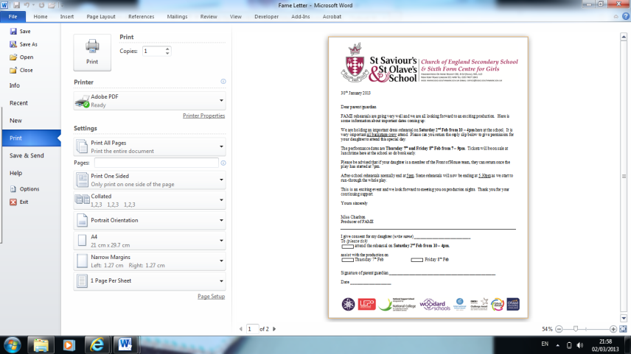
The letters will have a similar layout to this one, and also look similar to this one as they will contain the school logo and information.

Merchandising
T-Shirts
We’ve also decided to design t-shirts in order promote FAME, as we feel that this method can help attract the target market to attend the event due to popularity of the FAME musical. The t-shirts will be designed specific to the FAME musical, in which the people involved in the musical itself will wear them; this will make others aware of the event. The t-shirts will be specifically designed depending on roles in the musical, therefore the designs will differ, however they will all say ‘PA’ on them, relating to the name of the school in FAME (High School of Performing Arts- P.A.) The t-shirts will be worn within school, therefore advertising it to students and teachers as they are present within the school and will be able to see those involved wearing them, allowing them to associate them with the FAME event taking place shortly. Using t-shirts can also be very beneficial as they encourage the word of mouth advertising which is very important for our promotional campaign as it’s an internal school event. Word of mouth advertising will encourage students to purchase a ticket through social influences as they will want to attend if their friends are going. When students or teachers see others wearing the t-shirts it will then encourage the word of mouth with can then lead to them purchasing a ticket due to popularity of the event.
These are two of the designs that will be used for the t-shirts.

However, as we don’t have the physical resources in school to create the t-shirts, it means that we will have to get them made externally out of school. We’ve decided to get them done at a photo centre in Greenwich called ‘LPS London’ as we found that the prices were reasonable, however it is quite some distance from school. The prices for the t-shirts are roughly around £4.50 per t-shirts depending on the quantity. We decided to only 25 T-shirts due to the restriction due to the budget, meaning only the main cast will be able to wear them. The pricing to print the t-shirts is £4.50 per t-shirts, therefore it will cost us a total of £112.50 to print 25 (25 x £4.50 = £112.50).

Sales Promotion
Ticketing

Sales promotion is another method we’ve also decided to use in order to promote the school musical event FAME. We will use sales promotion with the ticketing, as we will give the target market a chance to purchase tickets in conjunction with a special offer that will be provided depending on the number of tickets they purchase. The special offer will provide the target market a chance to get one ticket free if they purchase two (Buy 2 Tickets and Get 1 Free), allowing them to save money. We’ve decided to target this offer to all the target market in order to attract more viewers; however this offer will only be available for the event taking place on Thursday night. This offer is only available for Thursday as there will be less demand due to it being less popular than the showcasing on the Friday night, as Friday is expected to be sold out as it is the last day of the week as well as the event. We will also specifically target teachers with another offer, giving them the chance to attend FAME for free; however this is only if they help out for one night. Therefore the promotion provides them with the chance of helping out with FAME one night, and getting a free ticket for the event. The tickets will be printed on coloured card; the colour of the card will depend on whether the ticket is an adult one or a student one. The total cost for printing the ticket was £40, this is because it was coloured card therefore the price was slightly more than printing on paper, although this may affect our objective to spend within our budget of £250, it can also help us achieve our other objective to sell 550 tickets by 5th February 2013 for the FAME production as the tickets would look more appealing attracting more customers.

Gantt Chart
A Gantt chart is a type of chart which provides a schedule for projects, helping manage time efficiently. It displays both the finish and start date of tasks within a project stating when they should be started and finishes within an overall project. The chart breakdowns activities within a project, therefore we can used it to breakdown the activities we will have to do within our promotional campaign for the school FAME musical. We can make effective use of a Gantt chart for our project as it will state when we have to start and complete specific tasks just in time for the showcasing of the musical, allowing us to keep on track as it will state how long the activities/tasks will take, giving us enough time.

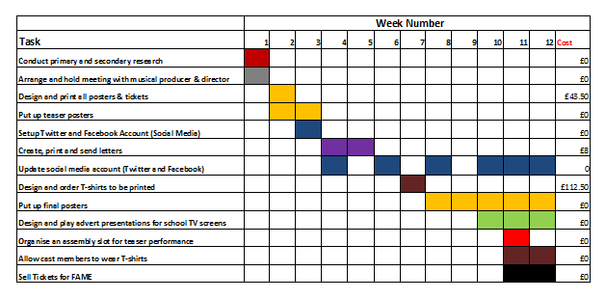
Our Gantt chart will include tasks which we will have to complete as part of our promotional campaign in order to achieve our aim to showcase the talents of the students of SSSO, by entertaining an audience which includes students, teachers and staff. It’s important that we have a Gantt Chart as it allows us to follow it in order to make sure tasks are completed in time for the musical, it is also very important that we stick to chart in order to make sure tasks are completed when we need to make use of them for our promotional campaign. It is especially important as the date of production can’t change; this is due to external factors as it is a school event therefore the school will decide when the date is set so specific reasons.

The image above shows the Gantt Chart that we used for our promotional campaign, showing the order in which we completed our promotional activities whilst also showing when we started then and how long they took us to complete.

Other posters also places in classrooms therefore make sure they’re placed in popular places
Posters have to be put up in busy and popular places
Feedback
Sender
Message
Receiver
Feedback
Message
Message
The promotional team (us), representing St Saviour’s & St Olave’s
“FAME the latest school musical is showing on the 7th & 8th February at 7pm”
Posters and letters
“FAME the latest school musical is showing on the 7th & 8th February at 7pm”
Students, parents & teachers
We have to make sure the posters and letters we out up have specific details such as the time, location and dates
NOISE
NOISE
Working hours, therefore people may be too busy to read letters
Purchasing FAME tickets
Ignoring it
Not buying tickets
Purchasing FAME tickets
Ignoring it
Not buying tickets
Talent show & Eucharist also taking place
Absent, didn’t see poster
Form tutors may not bother outing up posters, therefore put them up in other popular places.
Students may not give letter to parents, therefore could sent them by post but this would increase costs and we have to stick within our budget
Bad weather could delay letter posting

AO3
Customer Attitudes

In order to find out more about our customer attitudes, we conducted both primary and secondary research based on our target market. We conducted our primary research using both quantitative and qualitative methods by creating questionnaires and also done a consumer panel on our potential customers which helped us make decisions for the promotional activities we would use. As part of the primary research, we created separate questionnaires for both students and parents asking them different questions. For teachers we decided to use a qualitative method for our research by doing a consumer panel, as we felt it would be easier to ask a panel of 5 teachers’ questions in person as they may not have time to fill out questionnaires.

The information that we collected was very useful for us as we used it to the make decisions, for example, the student questionnaires allowed us to then make decisions about which colours we would use for the posters that would be put up for the musical. This helped us use the colours that the students found more attractive as we took their opinions into consideration when creating and designing the posters. The information from both the questionnaires and the consumer panel affected our promotional campaign as we asked questions which could then help us with the promotional activities, for example asking how much they were likely to spend on a ticket help us decided the price at which we would sell our tickets at. Through our primary research, we were also able to identify customer habits, such as were students mainly go at lunchtime, this then allowed us to consider putting up posters in these locations in order to attract a larger number of customers. Other primary research including the questionnaire for parents, allowed us to identify the characteristics of our customers, in this case the parents, as we could then identify which age category the majority of parents fall in, whilst also being able to see whether they are middle class or working class helping us make decisions on the pricing of our tickets as we wanted to make sure it was a reasonable and affordable price.

The secondary research also helped us with our promotional campaign especially with the pricing and costs of particular promotional methods we would use. As we researched into the costing of getting our posters, letters, tickets and t-shirts printed externally, it then made us make the decision to print the posters, letters and tickets internally in school as it would be much cheaper for us. However, we had to get the t-shirts printed externally as the school did not have the necessary equipment to do this. We conducted this research by finding out the costs of these facilities in both school and externally, and then we came to the decision of printing everything in school except from the t-shirts. Our secondary research also helped us reject using some promotional methods such as the billboards, and TV adverts as it is an internal school event which is only open to the students of St Saviour’s & St Olave’s and the parents as well as teachers and therefore don’t want to attract others as it not open to public.

As mentioned, we used questionnaires for primary research before the musical was showcased in order to get the views of the target market which would then help us make decision for our promotional activities. We also decided to use questionnaires again after the showcasing of the musical to get the feedback of the audience. The questionnaires varied depending on what category the target market where (student, teacher or parent). The questionnaires where then given out after the performance and had questions relating to the promotional campaign. All the questionnaires had the same questions except from the 3rd one which changed depending on the category. We managed to get 100 students to fill out the questionnaires, 40 parents and 20 teachers. The feedback from this then allowed us to assess how successful our promotional campaign was based on the activities we used and the decisions made in order to attract the target market. The results from the questionnaires are shown below on pie charts.

The pie charts above show the results of the questionnaires that we got students to fill out after the musical was showcased. This then gave us the knowledge of how successful the promotional activities that we used were, allowing us to then see how well the promotional campaign was overall. Looking at the results we were able to notice that the most successful promotional method for students was the assembly, this may have been because it was a captive audience and the assembly provided a teaser of the musical as a bit of it was performed.

The previous pie charts show the results from the parent questionnaires after the event. We were able to get 40 parents to fill out the questionnaires, therefore results varied. Looking at the result, the first question that was asked shows that the parents overall didn’t find any of the advertising methods useful, this would have been because they were not present within the school as most promotional activities were used within the school, therefore the only of them seeing it was if they came to pick up their child, in which they may have seen a poster, as the results show. The second question shows that the main reason for parents attending the event was due to supporting family and friends, this is the answer we expected. The third question we asked was different from the questions we asked in the student and teacher questionnaire. The results show that parents found that the letters which they received were very useful, meaning in the future the school may decide to use this approach again due to the successfulness of it looking at the feedback from parents.

The pie charts above are the results from the questionnaires on teachers we conducted. Analysing them, the first question shows that the most useful method teachers found was the assembly similar to the results from the students was the assembly; again this may have been due to the audience being captive. The results of the second question show that teachers mainly attended in order to support friends, family and students, which was predicted as many teachers would attend in order to stupor their students. The results on the last question about letters being put in pigeon holes shows that it encouraged them to some extent, therefore this infers that they may not have found it as useful as other promotional methods such as the assembly, however a small number of teachers did say it definitely did encourage them to purchase a ticket, whereas others said no and not really, therefore we may refer back to these results for letters in the future when using this promotional method for teachers, allowing us to then decided to target them differently considering to use informal methods such as posters.

AIDA & Objectives

AIDA refers to the four stages which have to be taken by your target market in order to for a business to sell their product or service. This approach is used in order to alter buyer behaviour as it’s a method which aims to persuade target customers into buying the specific product or service a business is trying to sell. AIDA is an acronym which stands for Attention, Interest, Desire and Action. A business will use different promotional methods depending on each stage of AIDA. As part of our promotional campaign for the showcasing of the FAME school musical, we will use to AIDA in order to target our customers. Referring to the four stages of AIDA we will use different promotional methods to target our market depending on each stage.

Attention
The first stage of AIDA is attention, therefore we have to attract out target market to the musical as we have to grab the audience’s attention. As it is the first stage, it means that it will have to create awareness of the musical therefore informing students, teachers and parents that it is taking place. The main promotional objective for this stage is to raise awareness of the musical; this is also one of our objectives for the promotional campaign. As we want to attract customers to the event, we have to be persuasive through the promotional activity we choose at this stage. As we want the attention of our target market, it means we will have to inform potential buyers of the musical. As our target market is students, parents and teachers, it meant that we may had to address different tones depending on who it is, as we would choose to take a formal approach to parents however more of an informal approach for students and teachers. At this stage, not only did we have to consider tone and content of the message that we were trying to communicate, we also had to consider the type of promotional activity that would be most suitable for us in gaining the attention of the target audience. We also had to think about how the promotional activity will be delivered in terms of which medium or media that will be used as well as how often we plan to repeat the message, how frequent it will be. We also had to consider whether we wanted to take a direct approach or not, depending on whether it’s a niche market or not.

We then decided that we would use a different tone and content for students, parents and teachers as we felt we may have to address them in different ways. We decided the tone for parents would be formal and therefore we would grab their attention through the use of letters writing to them in order to create awareness of FAME. For teachers and students, we would use an informal approach as they are internally part of the school, this would then we the best way to grab their attention. Considering the different types of promotional activities we could use, we felt that posters was the best approach at this stage however we would have to also use letter, but only for parents in order for that formal approach in order to achieve the objective ‘To make sure at least 20% of tickets are sold to parents of St Saviour’s & St Olave’s by 5th February’. The delivery message would have to be persuasive in order to attract potential customers and create awareness of the event persuading our target market to buy tickets for FAME. The main medium we have chosen to use is posters, as we feel that this is the most appropriate for the kick-off of our campaign. As we will use posters, we discussed the frequency of this and came up with the decision to release three different posters, the first being the teaser one which gave little information away, the second and final ones which gave more information displaying all the details of the musical such as time, dates, ticket pricing and selling information.

The posters that were created were attention grabbing; therefore the colours we used were quite bright whilst also taking on board the feedback from the questionnaires we conducted for our primary research. We also had to make sure that the designs of the posters were attractive and that they were appealing to students. We displayed and put up the posters in forms rooms as well as the lunch hall, foyer and library as these were the main places students spent their lunch times, and therefore likely to pick on the event as they’re spending time there – out primary research through the feedback from questionnaires also helped us make this decision. Form tutors were also likely to state the new posters that they’re putting up when received in their registers, creating awareness of the event. The language on the posters had to make the viewers excited therefore we used exclamation marks in order to make out that they cannot miss out as it is the school production of the year. We also placed reminders on the SSSO TV screens with the posters making sure many students if not all are aware of the musical. We also decided that in the first week only A4 posters will be put up, as it would cost too much to put A3 one up at this stage however later on A3 posters will be put up. When the word of mouth is increasing, then the A3 posters will be put up in which details of timings, location dates and ticket details will be including however this was a later stage than the first week.

Interest
The second stage of AIDA is interest, in which we have to create and stimulate buyer interests, being aware of what potential customers want out of the product or service. At this stage, potential customers will now understand the benefits of the service, in order to meet their needs. We will have to understand what the target market want the benefit out of the event as they will be able to gain more of an insight about the details of FAME. We will have to focus on how the event will meets customer needs and promote features of the musical whilst highlighting the benefits of the musical. As this stage focuses on the interests of potential customers, it moves potential buyers from passive towards active and consideration of the event merits, therefore students, teachers and parents will be more interested in the musical wanting to find out more about it.

At this stage, the musical will appeal to personal as well as psychological and social influences for the potential buyer. Personal and psychological influence for students would be supporting friends, whereas for the parents it would be supporting their daughter, and teachers would attend to support students and the school. Social influences for the students would be that they’re interested because it a popular school event that everyone is talking about and their friends are going.

For this stage, we decided to use social media including Twitter and Facebook as we felt it gave potential buyers a chance to find out more information if they are interested. We felt that the use of Twitter could be very beneficial for both buyers and event as it would give buyers a chance to find out more whilst also making the event more popular. The Twitter URL was on posters so the target market were able to visit the Twitter page to find out more about what the production is all about. The Twitter feeds also allow them to gain more of an understanding of the musical; this then shows an interest from the audience. The TV screens which are located around the school also included a teaser for the production allowing the target audience to get to know more about FAME. As we decided to use different Medias, it helped increase the word of mouth which led to others talking about the production increasing popularity of the event. Generally, this stage focuses on the interests of potential buyers as they will look for the highlights of the outcome from the event looking more into details. The different Medias that we used at this stage allowed us to display information about the musical, meaning the potential buyers that were interested in the event could find out further information and details through visiting the Twitter and Facebook pages as well as looking on the SSSO TV screens.

Desire
The next stage of AIDA is desire; this stage refers to development therefore convincing potential customers that they will miss out if they don’t buy the product or service. This means that through our promotional activities, we have to convince that they cannot miss out on the FAME event as they must attend. We should provide genuine incentives making our target market to make a purchase for a ticket. As this stage is about the development of the customer interest in a product or service, it means that we will have to encourage them to purchase a ticket for the musical making them develop a favourable attitude towards the school event. At this particular stage the potential customer will be willing to investigate more about the musical as they have an interest in it and therefore will be more likely to purchase a ticket.
As the target market will be more drawn to the event at this stage, it means we had to communicate the incentives, making the event seem like they couldn’t miss it due to the popularity of it, this would then encourage their decision to purchase a ticket. Communication is very important during this as we want to attract students, teacher as well as parent to attend FAME, meaning we will have to communicate with all of them using the correct promotional activities encouraging them to purchase a ticket. Through the communication using the promotional activities we must give also must information as possible in order to reassure them that they must attend the event as it will be amazing. On our final poster we including a phrase about the event stating that there is a limited number of seats, this will then further convince the potential customer to purchase one as they don’t want to miss out.
We had decided that the best way to attract the target markets attention at this stage was by using a promotional activity which would show them what the event would be like; we then decided to do this through an assembly slot which would demonstrate a part of the musical itself. The assembly slot had to of the target market present which was both students and teacher, the assembly meant it was a captive audience; therefore they would be more likely to show an interest for the event. The assembly slot was roughly a 5-10 minute showcase as was not available to have the whole assembly on FAME due to other school factors and decisions. FAME could hugely benefit from the assembly as it would create a buzz causing the students to look forward to the event, this would then help reassure us that our objective is achieved to create awareness by 90% by 5th February, measured through the use of questionnaires. The assembly slot also gives the target market an opportunity to gain more information about the event, also on where the tickets can be bought, helping move on from the attention stage. During the assembly, it was also said that there is a limited amount of seats, then helping them to be much more eager to buy tickets.

Action
The final stage of AIDA is action which is when you’re convincing the target market/potential buyers to purchase the product/service. At this stage, the potential buyer has already had desire for the product as they are interested in it; therefore the correct promotional activities have to be used in order to provide the final push to get the customer to actually purchase your product. This stage it very important as it is when the target market actually buys the product, which is what you want to gain out of it, this can then help a business achieve its objectives and aim. This is when the customers turn their intention to purchase into a confirmed scale, as they will then actually make the purchase.
It is important that the right promotional activity is used in order to encourage the customer to make a purchase, for the FAME musical we chose to use personal selling at this point as it plays a big part at this stage allowing us to target our target market which is students, parents and teachers helping us then achieve our objective to sell 550 tickets by 5th February 2013 for the FAME production. At this point we also mentioned ‘Limited number of seats. Friday has already been sold out’, this then makes the event seem very popular making our target market wants to purchase a ticket as soon as possible due to demand as they don’t want to miss out. Using personal selling means the students and teachers can directly buy the tickets, and students can purchase them on the parent’s behalf. Students will be able to purchase the tickets for FAME at both break and lunch time, therefore the majority are students who will come to see the production as intended as they’re our main target audience, helping us then achieve our objective To make sure at least 60% of tickets are sold to students of St Saviour’s & St Olave’s by 5th February.
As we chose to use personal selling at this stage, we could have also used letters sending them home to parents allowing them to purchase tickets as it would be targeting directly marketing them. We sent letters home at the desire stage instead, however it could have been an action if the letter sent home had a ticket request slip attached.
At this point the customer will have been through all the previous stages of AIDA, therefore it will be easier to gain interaction from audiences as they would have been aware of the musical and also interested and willing to find out information and purchase a ticket. As there are also a limited number of seats available for each night, it would encourage them further to purchase a ticket.
Overall, the various stages of AIDA helped us achieve our objectives as the attention and desire stages helped achieve the objective to create awareness of 90% by 5th February, among students, teachers and parents the use of different Medias such as posters and TV screens. The attention stage then helped achieve the objective to sell 550 tickets by 5th February 2013 for the FAME production, due to targeting out target market of students, teachers and parents.

Available Business Resources

The promotional campaign we done for the FAME musical meant we had some school resources available to us internally within school as it was a school event, this meant the costs were also lowered saving us from spending money externally.

As it is a school, it meant we had a number of students and teachers help us with part of our promotional campaign, for example media a-level students helped us with our promotional campaign. Our human resources used meant that we had the necessary skills and expertise as teachers and other students helped us for specific tasks as part of our campaign. Having the help from our teachers meant certain tasks could take place as they had the authority, for example the permission to sell tickets at break and lunch in the school foyer. A-level media students also helped us with the designing of posters and presentations, as they had the appropriate skills and expertise to create medias that will be successful and appeal to the target audience. The media students had both technical and creative skills which are essential for a successful promotional activity, this allowed effective posters and presentations to be created. Even though we had the help from teachers and media students, it was limited as had their own tasks and work to do at the same time, however we did use their skills as much as possible, but it meant we had to get to complete tasks during a certain time in which they were free.

As business students ourselves, we were also able to use our skills to make decisions and to complete specific tasks, for example deciding which promotional activities to use as part of our promotional campaign.

We made effective use of physical resources as we had school facilities available to us including the equipment needed for printing and designing posters and letters. We used the physical resources that were available to us very wisely as we decided to use all the equipment we could within school internally rather than getting it done externally as it was cheaper within school, for example the printing. All the physical resources which were used for the promotional campaign of FAME was all internal, lowering our costs helping us to achieve our objective to spend within a budget of £250, however we did have to get t-shirts printed externally at a digital printing shop as we didn’t have the equipment to do this at school. As we used the internal school equipment for printing, it meant the pricing was much cheaper than getting it printed externally; therefore the amount we spent was reasonable. We also used the schools physical resources for our promotional activities including the assembly slots and adverts on TV screens as the SSSO TV screen were used as they were located around school which meant they were visible for our target audience helping us create awareness for the event, referring back to our objectives. For the assembly slot, we used the school microphones, speakers and sound system as it meant it was available to us for free, therefore making the most out of the physical resources that were available to us within school.

For the FAME musical promotional campaign, our budget was £250 in which we spent it on our promotional activities helping promote the campaign. Most of the budget was spent on the printing of posters, letters and tickets in which we paid the school MRO department as we printed the necessary resources there and used their equipment to do so. Some of the physical resources which were used were also free to us, meaning we didn’t have to pay to use them such as the sound system, tables and chairs. We also had to pay for the t-shirts that we got printed, as they were printed externally as a digital centre in Greenwich, in total we paid £112.50 for the printing of 25 t-shirts at £4.50 each. In total we spent £164 of our budget on the printing for t-shorts, posters, letters and tickets, spending £51.50 of it within school for the posters, letters and tickets, and £112.50 of it externally for the t-shirts. We underused our financial resources that we available to us as we spent under our £250 budget, this meant we achieved our objective to do so however it also meant we could have spent more on other promotional methods which could have helped attract more customers or increased the popularity of the musical, for example texting the parents informing them of the event.

Overall, we used all the physical and human resources effectively, however could have made more use of the financial resources that were available for us to use, but as we did not spend over our £250 budget, it allowed us to achieve our objective not to exceed this amount and spend within I, however in future we may decide to spent more on other methods in order to attract more of our target audience.

AO4
Evaluation

The overall promotional campaign for the FAME musical went very well and was successful in terms of accomplishing the overall aim which was ‘To showcase the talents of the students of SSSO, by entertaining an audience which includes students, teachers and staff.’ As well as having an aim for the promotional campaign, we also had a number of SMART objectives that we wanted to achieve, which were:
- To sell 550 tickets by 5th February 2013 for the FAME production.
- To create awareness of 90% by 5th February, among students, teachers and parents, measured through the use of questionnaires.
- To make sure at least 60% of tickets are sold to students of St Saviour’s & St Olave’s by 5th February.
- To make sure at least 20% of tickets are sold to parents of St Saviour’s & St Olave’s students by 5th February.
- To make sure at least 5% of tickets are sold to staff of St Saviour’s & St Olave’s by 5th February.
- To spend within a budget of £250.

We managed to achieve all our objectives except for one which was ‘To make sure at least 20% of tickets are sold to parents of St Saviour’s & St Olave’s students by 5th February’. Reflecting back on this, I meant we could have done things differently in order to make sure we achieved this in order to sell a larger percentage of tickets to parents. We didn’t achieve this goal as we didn’t use as many promotional activities as we could have in order to target the parents, as they were also our target market. We used more promotional activities to target students and the teachers as it was easier as they were present in school allowing us to target them both at the same time, however the parents were not in school and rarely came to pick up their daughters, therefore we felt that it was much harder to target them. To target the parents, we used letters in order inform them about the musical formally, however the letter only told them that the event was taking place and details about the ticket selling. As he letter only informed parents of the event, we could have also included a ticket request slip as part of the letter in order to encourage the action stage, referring back to AIDA. If we had used that, it may have helped up achieve the objective of selling at least 20% of tickets to parents, however the use of ticket request slips would have also been too complicated in terms of having to them send tickets to the parents in case students lost them and we also didn’t want students to be carrying the money to purchase the tickets on behalf of their parents. We wanted to
110 tickets to parents however only managed to sell 85 tickets, therefore as a result in future for a school production we may decide to use more promotional activities to target parents for example considering sending a text to parents, we could have done this as we spend under our budget therefore would have enough money to do so.

One of our objectives were to sell 550 ticket by 5th February for the FAME production, we achieved this as we managed to sell 557 tickets by the 5th February, showing that the variety of promotional activities we used were successful. We also achieved our objective to make sure at least 60% of tickets are sold to students of St Saviour’s & St Olave’s by 5th February, we were able to achieve this as students were our main target audience and were also present in school, therefore it was much easier to target them compared to parents. We also achieved the goal of selling at least 5% of tickets to staff, as we sold more than this selling 42 tickets to the staff, this reflects that the promotional methods we did to target them were successful as we used both posters and letters, therefore could consider using them again in future. Another objective for our promotion campaign was to create awareness of 90% by 5th February, among students, teachers and parents, in which we would then measure through questionnaires. We managed to achieve this as we conducted questionnaires straight after the production ended in the school hall asking students, teachers and parents questions. The results of the questions were positive as we asked 100 people and 90 said yes that they knew about the event by the 5th of February, therefore achieving our objective. (The results are shown below)
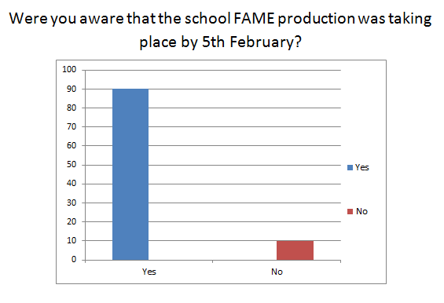

We managed to alter our customer attitudes as we wanted for both students and teachers, however not so much for parents as we didn’t manage to sell as many ticket to parents as we aimed to. Using the stages of AIDA we were able to use a variety of promotional activities which allowed the target market to show interest in the FAME production allowing them to then take action to actually purchase a ticket, accomplishing the overall goal. Using the feedback from the questionnaires we conducted in advance to the production we were able to use the results for making decisions about the types of promotional techniques we would use and how we design and carry out these activities. I would say the most successful questionnaires were the student’s questionnaires rather than the parents as we achieved the objective to sell 60% of tickets to students however didn’t achieve our 20% goal for parents. We didn’t only use the feedback from the questionnaires, but all our primary research including the interview with the producer and director or FAME as well as the consumer panel when asking teacher questions as we didn’t use a questionnaire on them as we felt it would be much useful asking them in persona allowing us to them ask them open questions.
As we didn’t achieve the goal we set to sell 20% of tickets to parents, referring to AIDA it may mean the promotional activities we chose to use were not as successful as the methods used for teachers and students. We may not have got the attention of the parents, therefore they may not have been willing to find out more about the musical and show and interest, therefore not having a desire to attend, leading to not actually making an action and purchasing a ticket. As we chose to target the parents in a formal way in order to look professional, we sent them letters informing them of the event, however this may have been the reason why the event didn’t appeal to them as much, and could of then chose to take a more informal approach by maybe posting them the posters of the event as it would have been more appealing also allowing them to show an interest as the poster had details of the event on it. However if we chose to send the posters to parents by mail it would have increased our costs and may have affected our objective to spend within out £250 budget. We could have also texted parents about the event, but yet again this would have increased our costs. Referring back to the results of our primary research, the results from the questionnaires we conducted on parents show that 50% of parents preferred email as a method or communication and 30% preferred text, we didn’t use either of these methods to communicate with parents, therefore we should have done so in order to achieve our objective of selling 20% tickets to parents.
Our overall use of the resources we had available was efficient as we used them wisely, however could have made more effective use of our financial resources as we spent under our budget. Even though we spent under our budget, it meant we achieved our objective to spend within £250. As we didn’t sell as many tickets as we wanted to parents, this meant we could have used the financial resources that were available to use to do so, meaning we could have sent parents a text in order to encourage them to attend the event and purchase a ticket, therefore a next time we could do this to encourage action from parents. We could have also used the financial resources more effectively to post other information such as posters to the parents, possibly attracting more of our target market. Other than financial resources, we used our human resources and the physical resources that were available very efficiently as we decided to use the skills and expertise of both teachers and students in the school in order to complete tasks and make particular decisions. As it was a school taking place at school, it meant that our labour was free as we had teachers and other students partly helping us for specific tasks in our promotional campaign, for example media students helps us design posters, this was free as we didn’t have to pay for their expertise, making effective use of people available. We also made use of the physical resources that were available within school as we found it very useful as it meant we were able to use some things free of charge or get some things done cheaper. We were able to use the sound system, microphones and speaker free of charge for the assembly slot which we found beneficial helping us stick to our budget, we also got the printing of posters, tickets and letters done within school at a cheaper price making efficient use of the resources such as printer and computers.
Generally, our promotional campaign for the FAME musical production was very successful and we achieved our aim ‘To showcase the talents of the students of SSSO, by entertaining an audience which includes students, teachers and staff’. We also managed to achieve all out objectives except from one, therefore if were to do the campaign again we would do particular things differently in terms of the promotional activities we would use in order to achieve the goal to sell 20% of tickets to parents. In future, to attract more parents we would use more mediums to appeal to the parents; for example, we would text and email parents in order to communicate with them informing them on the musical and encourage them to purchase a ticket. We would also use more of our budget as we didn’t use all of it, allowing us to them text parents or mail them posters about the musical. As we approached parents in a formal way, next time we could approach them using a variety of both informal and formal methods as this may catch their attention, for example we could use posters next time and consider posting them or emailing them to parents. Overall, everything else went well for the promotional campaign and was a success.
Appendix
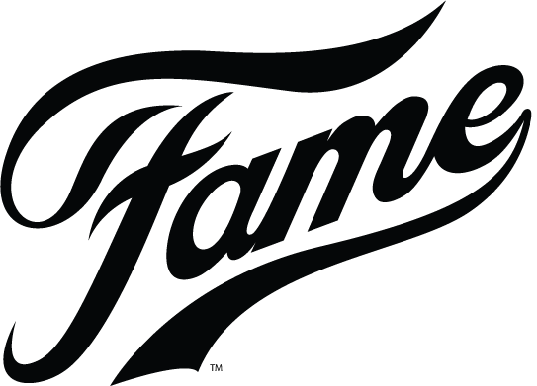
Questionnaire for Students

- What colours do you find attractive?

Please circle

Black & White Red & Black Blue Don’t Know

- Where do you usually spend your lunchtime and break?

Please circle
Foyer Form Room Outside Canteen All of the above

- Do you look at the school TV screens for information?
Please circle
Yes No

- How much would you be willing to spend on a ticket for a school event?

Please circle

Less than £1 £1 £1.50-£2 More than £2

- Do you use social media such as Facebook or Twitter?
Please circle
Yes No

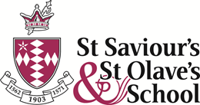
Questionnaire for Parents

- What newspaper do you read? (Please circle your answer)
The Times Guardian The Telegraph The Sun
The Metro The Evening Standard Other __________________
- What time is best suited for you to attend the Fame Production?
During school hours
3.30-5.30pm
5.30-7.30pm
7.30-9.30pm
________________________________________________________________
- What occupation do you currently undertake?
_____________________________________________________ ___________

- Do you regularly visit the school to pick up your child / children?

Very often Sometimes Hardly Never

- What age are you? (Please circle)
25 – 30 31 – 45 46+
- What is your preferred method of communication? (Please circle)

5 Email 3 Text 2 Letters Other____________
Thank you for taking the time to fill in our questionnaire
Questionnaire to member of staff
Consumer panel for 5 teachers

- Do you remember any promotional activities for the school musical that worked well in the past?

- Do you attend any school plays?

- How much are you willing to pay for a ticket?

- Do you use social media?

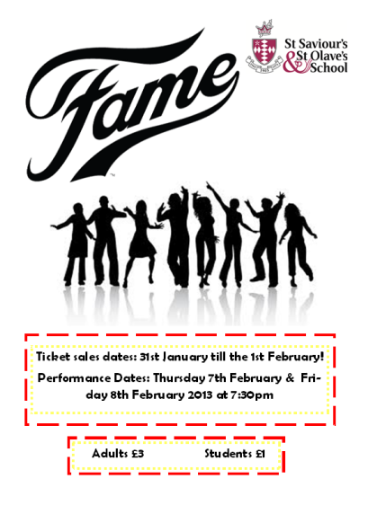
Second Poster
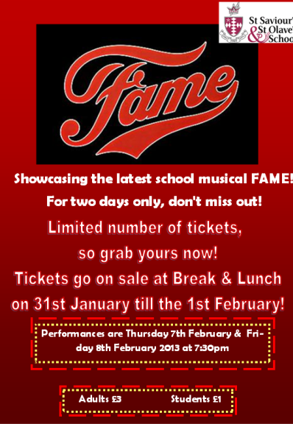
Final Poster

Teaser (First) Poster

Socioeconomic Research
The price for a flat near SSSO is round about £575,000. There are prices of three different flats with different amounts of rooms. This shows the price ranges of how much parents in the area would pay to live in the area where the school is located. The prices are high due to the area being in central London and the location is known to be the business area of London.
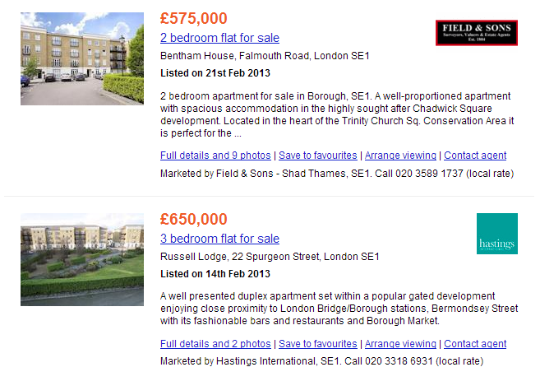
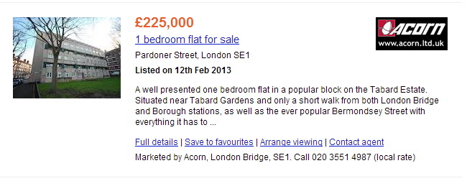
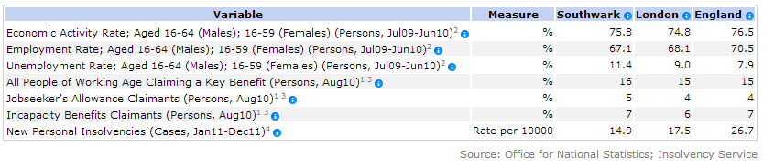The employment rate in Southwark is 67.1% which is quite high compared to other regions of the country. And this also indicates that the parents that are living in the local area near SSSO are mainly all working class citizens and many of the others may be housewives.

The box below shows the information about the pupils that attend SSSO. This information has been obtained from the Ofsted report that had been put together from an inspection. It shows the total number of pupils that are present at SSSO and this kind of information is important as the number will need to be taken into consideration as to how many of the students out of the 776 will go to fame and buy tickets as there are only 600 seats overall for both nights. Although, not all the seats will go to students as they are divided amongst parents, teacher and students.
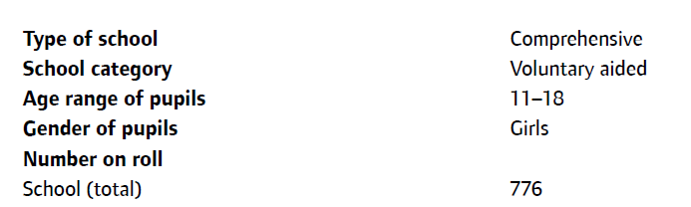
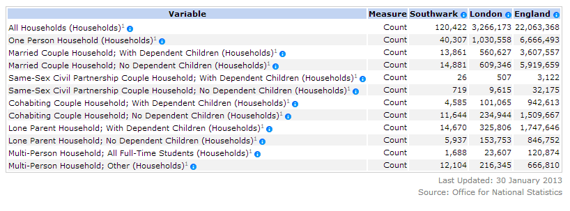
The information table above outlines the number of people living in a household as to whether the people are married or are lone parents. This is important information as to find out whether parents will be able to make it to the performance and whether the time that we have selected is appropriate for these parents as they have a busy schedule.
Secondary research:
Resources: | Number: | Price: | Sources:
Posters (A3) | 5 (A3) Posters | £2.50  (50p per poster) | School offices  (In house)
Posters (A4) | 40 (A4) Posters | £5 | School offices  (In house)
Tickets | 600 Tickets | £40 | School offices  (In house)
T-Shirts | 20 (8 Small sizes)  (6 medium sizes)  (6 Large sizes) | £112.50 | We printed our t-shirts with a small shop based in Greenwich called ‘LPS London’  (their website: http://www.londonprintservice.com/)  (Out house)
Letters | 85 (Teachers)  75 (Students)  (5p per letter)  (No sending costs because teachers will get the letter in their pigeon hole and students will be given letters to take home for their parents, therefore avoiding sending costs saving us money that can potentially be used for other important aspects of our campaign) | £8 | School offices  (In house)
Total costs: |  | £168 (Below our budget of £250)

Interviewing the director and producer of St Saviour’s & St Olave’s School musical FAME
Question: What is your overall aim?
Answer: To showcase the talents of the students of SSSO, by entertaining an audience which includes students, teachers and staff.

Question: When is the event?
Answer: Thursday 7th and Friday 8th February at 7pm in the school hall.

Question: What benefits does the FAME musical have for the students taking part?
Answer: It gives the students involved the confidence to perform to a large audience, and also the ability to help out with a large event. The students can benefit from is as they will be able to learn near skills as well as develop current skills as they will have to manage time whilst also having the work under pressure. Students will also develop team work skills, as they will be required to work in groups to achieve tasks.

Question: Who are your target audience?
Answer: Students allowing them to appreciate the talents of their friends and classmates. Parents, as it will reflect a positive image of the school and the pupils taking part. Teachers, as they will be able to see the talents of their students outside the classroom.

Question: Are there any specific methods or promotion you would like us to use?
Answer: Methods that are in keeping with our desire to involve as much of the school as possible.

Question: What methods have you used in the past for school related events?
Answer: Posters and assembly slot.

Question: What was the past price range?
Answer: £1 for a child (under 18) and £2 for adults.

Question: Who have brought the most tickets in the past?
Answer: There’s no clear record but we presume its students. We hope this year we have a type of ticketing system to help us keep track.

Question: What is your seating capacity?
Answer: Capacity of 300 per night however will need 10 reserved each night.

Dear Teachers,
I am writing to let you know about the fantastic school production that is going to take place on the 7th and 8th of February. The school production that is taking place is the incredible musical play Fame which may not be shown again at the school.
We and the students will much appreciate it if many of you teachers can come to watch the musical as this will help raise funds for the 6th formers prom and help encourage students taking part to work harder and show their best work with the amount of support by you.

If you’re interested in buying tickets there are still many left for both days which will be sold at lunch times in G4. Hope to see you there.

Twitter feeds



