FANASTCIAL (MYTHICAL) BEASTS
STARTER – What fantastical/mythical beasts do you know about? For example, dragons are mythical beasts.
Beast drawing

Characteristics:

Habitat:

Fantastical Beast Project –
Over the next few weeks you will be completing tasks that will help you design your own fantastical/Mythical beasts. Along with describing its characteristics/adaptions and its habitat or where it lives.

ARTISTS –
Many artists have created their own fantastic beasts. Have a look at some of them and answer the questions about their work.
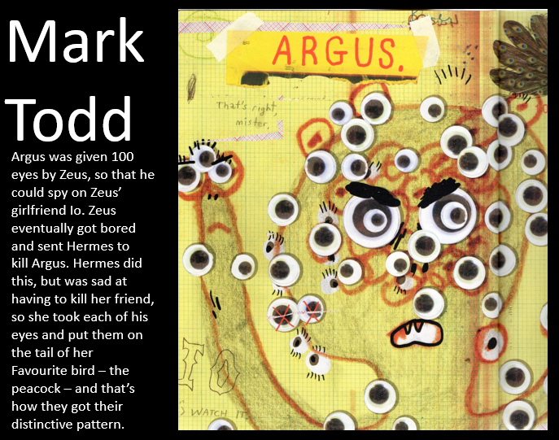
What do you find interesting about Argus?
What do you think he could do to improve this fantastic beast?

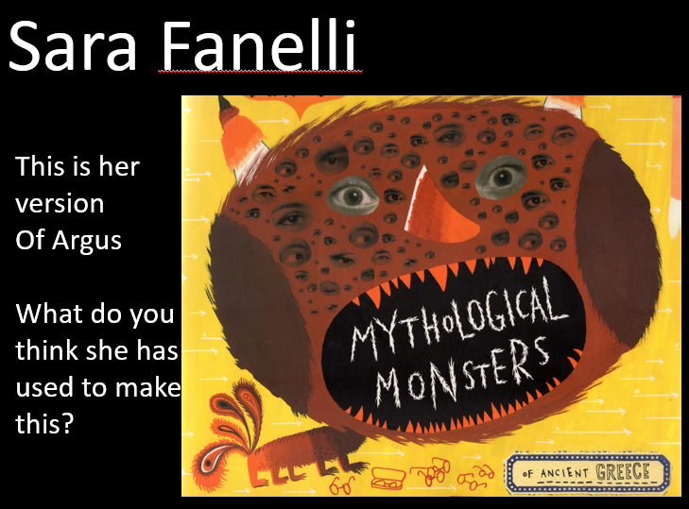

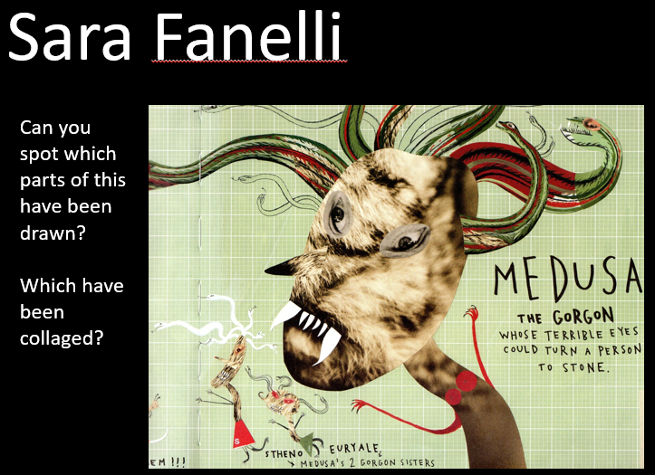
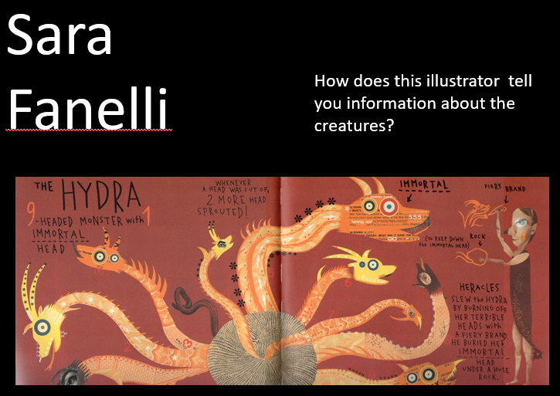
Task –
Start to create your own creature, by amalgamating parts of other animals. Use some ideas from the artists you examined, you can cut images of real animals out and mix and match them to help plan your creature. You might want to draw some parts (like Sara Fanelli does) -do this in pencil so you can change it if you need to. Use the A4 paper to create your BEAST!!! Don’t worry about the background yet...Just think about the creature!

Plenary –
What are two beasts that have cool characteristics that you would like to see mixed together?

